Assignment – Weekly Sales

Shaun Pritchard

Rasmussen College

QMB3200

Kimberly Powell

July,23 2020

**Assignment – Weekly Sales**

**Importing Files:**

I started by importing my data files using ***CourseProject_Weekly_Sales.sas*** for the following syntax as follows:

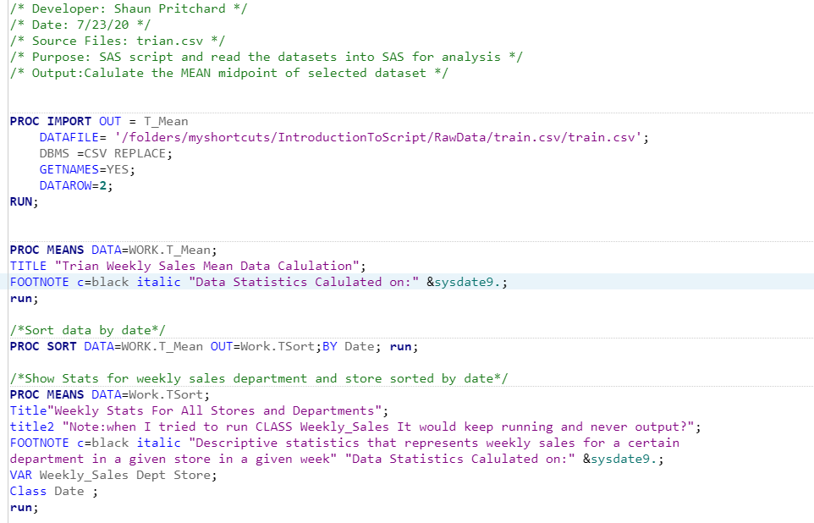

I was not able to group variable with the CLASS **Weekly_Sales** It would constantly time out on me. Also, I tried using the variables individually and it would also crash from running to long. Please advise?

I also tried coding it as shown in your lesson with temp data with a new program called ***CourseProject_Weekly_Sales2.sas*** with the following code***:***

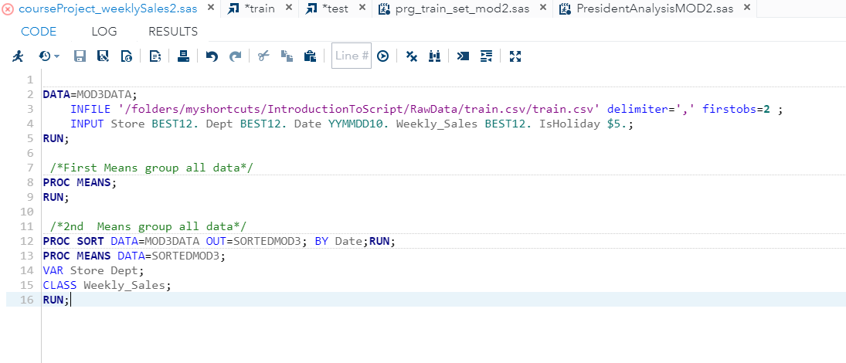

**Weekly Sales Trian.csv output with the first iteration:**

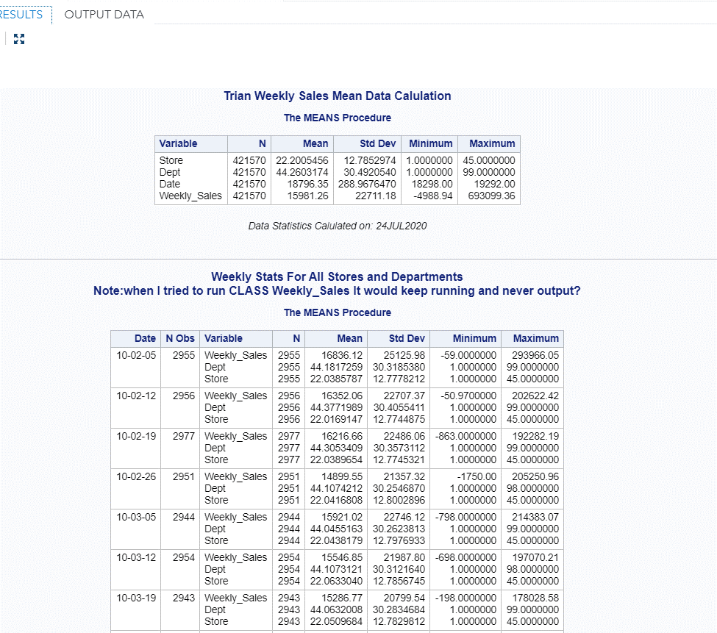

**Weekly Sales Trian.csv output with the second iteration:**

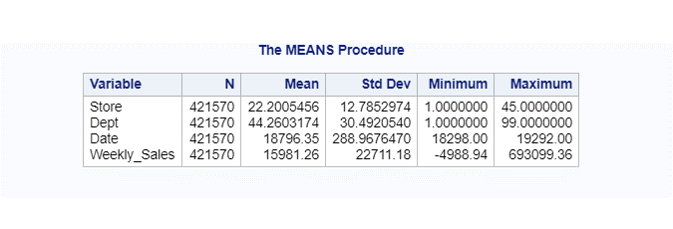

**Program would run and stall after 15 minutes of doing this. Please Advise?**